Day 3

1pm-3pm

INTRODUCTION TO BUILT-IN FUNCTIONS

Constants, Expressions and Formulas

Fundamentals of Built-In Functions

Accessory Built-In Functions

**Working with Arrays**

1. An array is a variable that holds multiple values assigned to array indices. An array must be declared before use.
2. To declare an array:

Dim array1(1 to 10) as string

‘if start index not defined, it start with 0

Dim array2(10) as string

1. To assign values to array

array1(1) = one

array1(2) = two

1. Or using the array function

Dim a as variant

a = Array(“Toyota”,”Honda”,”BMW”, “Mercedez Benz”)

1. To create a dynamic array

‘declare an empty array first in the global declarations

Dim dynamicarray() as string

‘then once you have recomputed the possible size (example: using counta) you can then resize the array using redim. ‘Using +1 is a good idea so you will always have an empty array index at the end, but note that the last array index will ‘always be empty.

Redim dynamicarray(newsize + 1)

1. Declaring multi-dimensional array

‘this creates 3 storage index for each of the first set of index (total of 9 indices)

Dim multidimarray(1 to 3,1 to 3) as string

1. Assign value to multi-dimensional array

multidimarray(1,1) = A

**VBA functions**

Here are some of popular VBA built-in commands

|  |  |
| --- | --- |
| Function | What It Does |
| Abs | Returns a number’s absolute value. |
| Array | Returns a variant containing an array. |
| Choose | Returns a value from a list of items. |
| Chr | Converts an ANSI value to a string. |
| CurDir | Returns the current path. |
| Date | Returns the current system date. |
| DateAdd | Returns a date to which a specified time interval has been added — for example, one month from a particular date. |
| DateDiff | Returns an integer showing the number of specified time intervals between two dates — for example, the number of months between now and your birthday. |
| DatePart | Returns an integer containing the specified part of a given date —for example, a date’s day of the year. |
| DateSerial | Converts a date to a serial number. |
| DateValue | Converts a string to a date. |
| Day | Returns the day of the month from a date value. |
| Dir | Returns the name of a file or directory that matches a pattern. |
| Err | Returns the error number of an error condition. |
| Error | Returns the error message that corresponds to an error number. |
| Exp | Returns the base of the natural logarithm (e) raised to a power. |
| FileLen | Returns the number of bytes in a file. |
| Fix | Returns a number’s integer portion. |
| Format | Displays an expression in a particular format. |
| GetSetting | Returns a value from the Windows registry. |
| Hour | Returns the hours portion of a time. |
| InputBox | Displays a box to prompt a user for input. |
| InStr | Returns the position of a string within another string. |
| InStrRev | Returns the position of a string within another, from the end of a string. |
| Int | Returns the integer portion of a number. |
| IsArray | Returns True if a variable is an array. |
| IsDate | Returns True if an expression is a date. |
| IsEmpty | Returns True if a variable has not been initialized. |
| IsError | Returns True if an expression is an error value. |
| IsMissing | Returns True if an optional argument was not passed to a procedure. |
| IsNull | Returns True if an expression contains no valid data. |
| IsNumeric | Returns True if an expression can be evaluated as a number. |
| LBound | Returns the smallest subscript for a dimension of an array. |
| LCase | Returns a string converted to lowercase. |
| Left | Returns a specified number of characters from the left of a string. |
| Len | Returns the number of characters in a string. |
| Mid | Returns a specified number of characters from a string. |
| Minute | Returns the minutes portion of a time value. |
| Month | Returns the month from a date value. |
| MsgBox | Displays a message box and (optionally) returns a value. |
| Now | Returns the current system date and time. |
| Replace | Replaces a substring in a string with another substring. |
| RGB | Returns a numeric RGB value representing a color. |
| Right | Returns a specified number of characters from the right of a string. |
| Rnd | Returns a random number between 0 and 1. |
| Second | Returns the seconds portion of a time value. |
| Shell | Runs an executable program. |
| Space | Returns a string with a specified number of spaces. |
| Split | Splits a string into parts, using a delimiting character. |
| Sqr | Returns a number’s square root. |
| String | Returns a repeating character or string. |
| Time | Returns the current system time. |
| Timer | Returns the number of seconds since midnight. |
| TimeSerial | Returns the time for a specified hour, minute, and second. |
| TimeValue | Converts a string to a time serial number. |
| Trim | Returns a string without leading or trailing spaces. |
| TypeName | Returns a string that describes a variable’s data type. |
| UBound | Returns the largest available subscript for an array’s dimension. |
| UCase | Converts a string to uppercase. |
| Val | Returns the numbers contained in a string. |
| Weekday | Returns a number representing a day of the week. |
| Year | Returns the year from a date value. |

Examples:

Msgbox “today is “ & Date

Msgbox “string length of data in A1: ” & Len(Range(“A1”))

Msgbox “the current month is ” & MonthName(Month(Date))

Ucase(Range(“A1”))

MsgBox Val("123") ‘gets number from a string

MsgBox Abs(-14) ‘gets absolute value of a number

‘using choose function

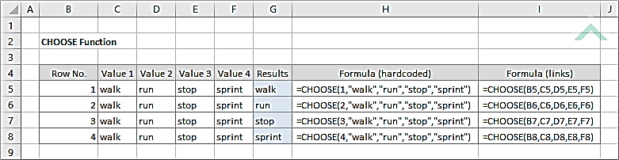

‘demo

IsArray Returns True if a variable is an array.

IsDate Returns True if an expression is a date.

IsEmpty Returns True if a variable has not been initialized.

IsError Returns True if an expression is an error value.

IsMissing Returns True if an optional argument was not passed to a procedure.

IsNull Returns True if an expression contains no valid data.

IsNumeric Returns True if an expression can be evaluated as a number.

Left Returns a specified number of characters from the left of a string.

Len Returns the number of characters in a string.

Mid Returns a specified number of characters from a string.

Replace Replaces a substring in a string with another substring.

Right Returns a specified number of characters from the right of a string.

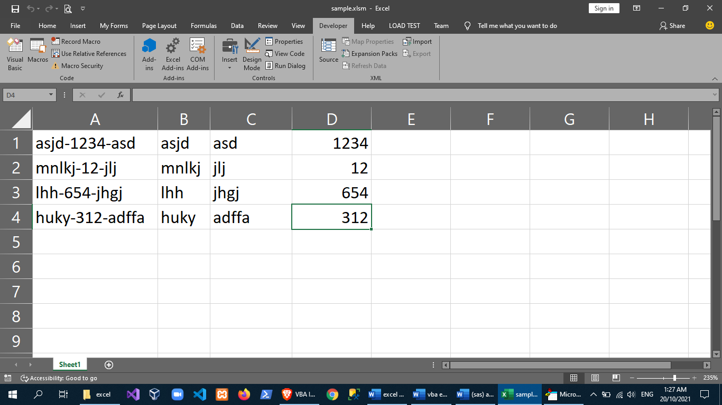

Sub testfunctions1()

Dim colcount As Integer

Dim r As Integer

Dim sstr As String

colcount = Range("A:A").SpecialCells(2).Count

For r = 1 To colcount

sstr = Cells(r, 1)

'get left part before dash

Cells(r, 2).Value = Left(sstr, InStr(1, sstr, "-", 1) - 1)

'get right part after dash

Cells(r, 3).Value = Right(sstr, Len(sstr) - InStrRev(sstr, "-", -1, 1))

'get the mid string between dashes

Cells(r, 4).Value = Mid(sstr, InStr(1, sstr, "-", 1) + 1, Len(sstr) - (InStr(1, sstr, "-", 1) + (Len(Cells(r, 1)) - InStrRev(sstr, "-")) + 1))

Next r

End Sub

using TextToColumns function

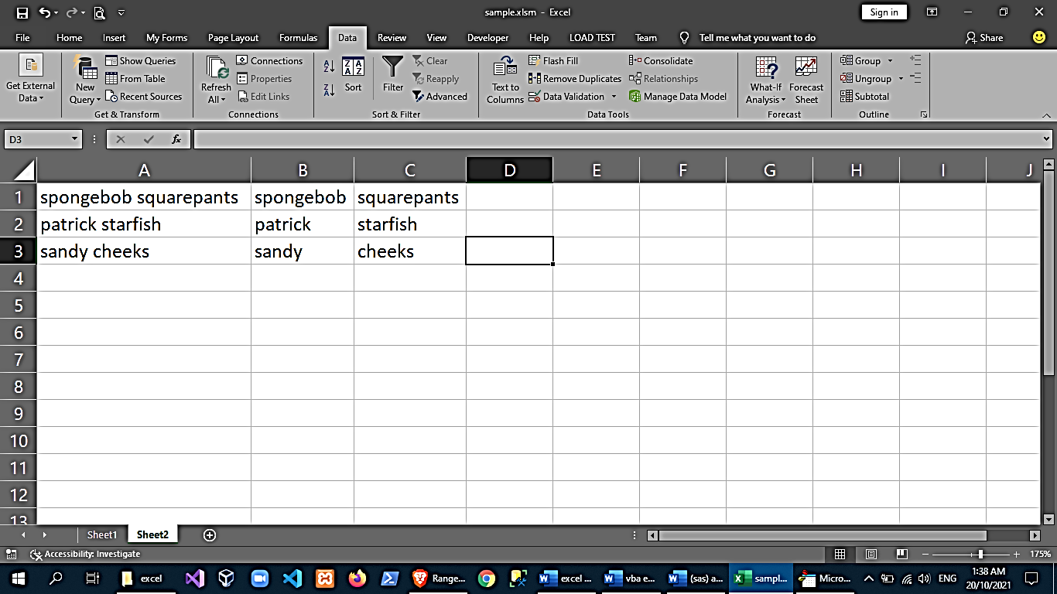

Sub testfunction2()

Range("A:A").SpecialCells(2).Select

Selection.Copy

'Worksheets("Sheet2").Activate

Range("b1").Select

ActiveSheet.Paste

Selection.TextToColumns DataType:=xlDelimited, ConsecutiveDelimiter:=True, Space:=True

End Sub

‘using find and replace

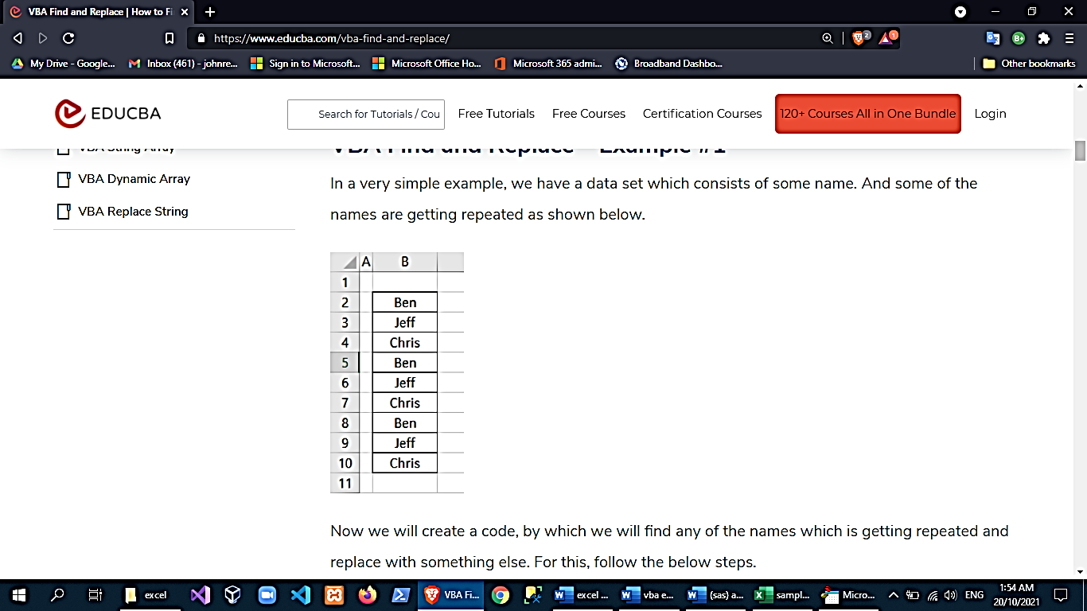

Sub Find_Replace1()

Range("B2:B10").Replace What:="Ben", Replacement:="Sam"

End Sub

3pm-5pm

**Using Worksheet Functions in VBA**

‘if there are functions in excel that you prefer to use, you can invoke the worksheetfunction object

Examples:

‘adding cell range using excel’s sum

Dim mytotal as double

Mytotal = Application.WorksheetFunction.Sum(Range(A:A))

‘the ff also gets the same answer

WorksheetFunction.Sum(Range(“A:A”))

Application.Sum(Range(A:A))

‘getting the maximum value in a range

Dim maxval as double

maxval = WorksheetFunction.Max(Range(“A:A”))

‘getting the second largest value

Dim secondbiggest as double

Secondbiggest = Large(Range(“A:A”),2)

‘sample using vlookup

Sub GetPrice()

Dim PartNum As Variant

Dim Price As Double

PartNum = InputBox(“Enter the Part Number”)

Sheets(“Prices”).Activate

Price = WorksheetFunction.VLOOKUP(PartNum, Range(“PriceList”), 2, False)

MsgBox PartNum & “ costs “ & Price

End Sub

‘sample using transpose function

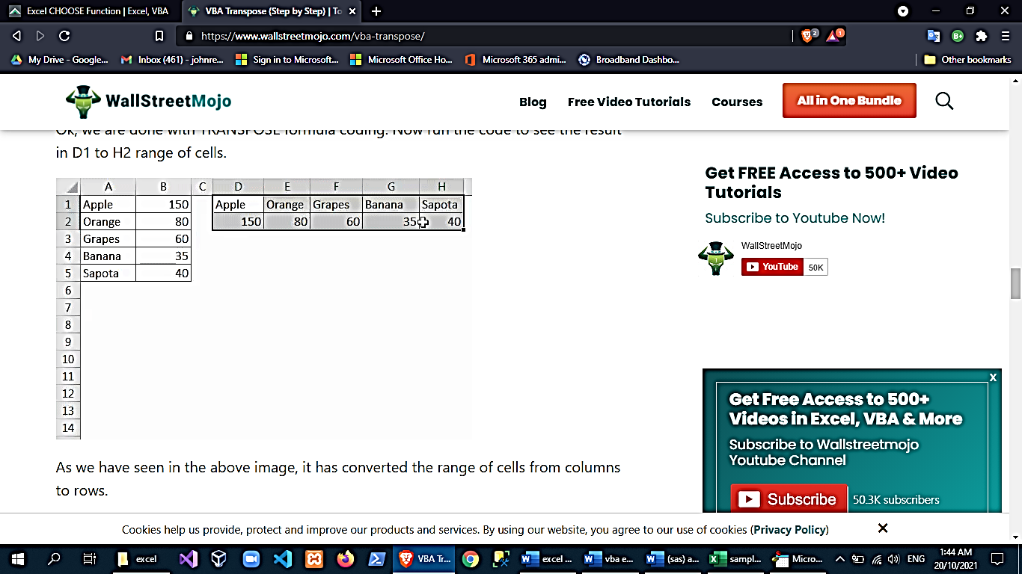

Sub Transpose_Example1()

Range("D1:H2").Value = WorksheetFunction.Transpose(Range("A1:D5"))

End Sub

**Entering worksheet functions**

‘you cannot copy-paste functions from excel to the vbe. You have to do your vba codes by hand but the following might come in handy:

1. Enable auto-list member in options (VBE tools🡪options🡪edito tab)
2. Type either worksheetfunction followed by a dot(.) then wait and view the list of available functions
3. Ctrl + shift after typing an object to view its functions or child objects

**Custom Functions**

‘you can create your own functions in vba

Example:

Function MultiplyTwo(num1, num2) As Double

MultiplyTwo = num1 * num2

End Function

Sub ShowResult()

Dim n1 As Double, n2 As Double

Dim Result As Double

n1 = 230

n2 = 2

Result = MultiplyTwo(n1, n2)

MsgBox Result

End Sub

custom functions that you create in VBA will be usable in excel too!

